**TEAM5OARS**

**SYSTEM TESTING**

**Test Cases with Screenshots**

***Version 2.0***

**Approvals Signature Block**

|  |  |  |  |
| --- | --- | --- | --- |
| **COSC 4351** | **Name** | **Signature** | **Date** |
| SE Team Leader | Visak Varghese |  |  |
| SQA | Luis Silva |  |  |
| DBA | Anthony Cortes |  |  |
| DBA | Nixom Mathew |  |  |
| TM | Sai Vadlamani |  |  |
| TM | Keith Russell |  |  |
| TM | Kaisong Fan |  |  |

**Date: __5/2/2016______**

**Role: Login Name: AccountControllerTest**

**Test description: Check that login is working properly**

**Screenshot of the outcome:**

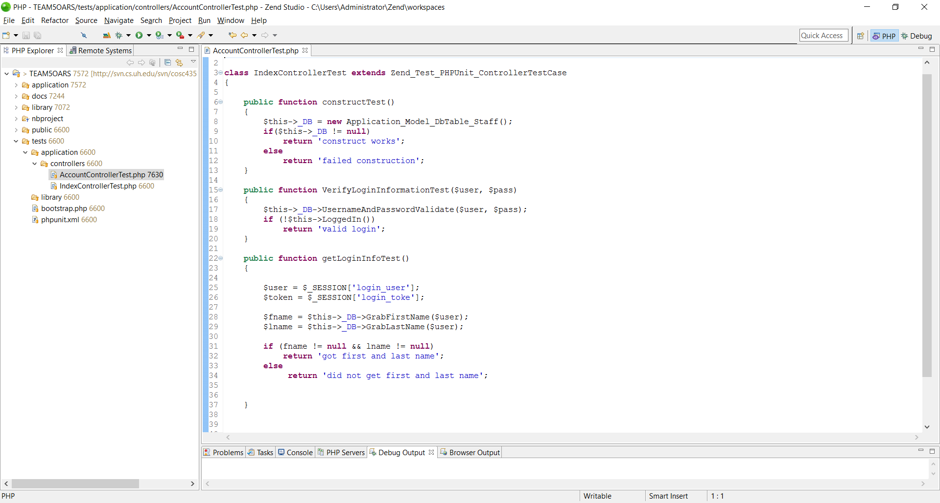

**Document Control**

Change History

**Table 2: Entries when work completed (SVN Commit Comment matches Description)**

|  |  |  |  |
| --- | --- | --- | --- |
| Revision | Name | **Completed Date** | Description |
| 1.1 | TL - Visak | 5/2/2016 | Did Login Test case |
| 1.X | SQA & Name | 5/2/2016 | Checked Document |

**Table 3: TL entry for RED DELIVERABLES (SVN Commit Comment matches Description)**

|  |  |  |  |
| --- | --- | --- | --- |
| Revision | Name | Due Date | Description |
| 2.0 | TL - Visak | 05/02/2016 | I changed Version to 2.0 |

Document Storage

This file is stored in SVN at http://svn.cs.uh.edu/svn/cs4351/team**?**/TEAM PROJECT DELIVERABLES/**SYSTEM TESTING SCREENSHOTS.doc**.